**DATA SCIENCE JOB SALARIES ANALYSIS**

My name is Adaramola, Temiloluwa Oluwaseyi. I am a data analyst tasked with performing a detailed analysis of data scientist salaries using Excel. Based on the emergence of remote roles around the world and many people transitioning into the world of data, this analysis will provide informative and actionable insights into the data ecosystem that can help in strategic decision-making.

**INTRODUCTION**

Data science, a dynamic and rapidly evolving field, lies at the intersection of data analysis, programming, and domain expertise. Data scientists are modern-day explorers, delving into vast datasets to uncover insights and patterns that drive informed decision-making. In this report, we delve into the multifaceted realm of data science careers, examining the experience level, job roles, and company size. I followed the universally accepted steps of analyzing data which are; **asking questions, collecting data, processing data, analyzing data and sharing results**. Join me as I navigate through the data-driven world and shed light on the diverse opportunities that the data science field offers.

**QUESTIONS**

Throughout this analysis, I will address six crucial questions that hold substantial insights for individuals contemplating a career path within the data ecosystem:

1. **Distribution of Jobs by Experience Levels**: What percentage of job opportunities are distributed among different experience levels within the dataset?
2. **Predominant Job Type**: Across the studied years, which job type prevails as the most common within the dynamic Data Science sector?
3. **Average Earnings by Experience Levels**: How does the average earning potential of data practitioners correlate with their varying experience levels?
4. **Salary Trends by Company Size**: What is the average compensation that companies offer to data employees, relative to their company size?
5. **Earnings Based on Employment Type**: How do the average earnings of data practitioners differ based on their specific employment type?
6. **Average Income by Job Title**: What is the potential average income tied to specific job titles within the data sector?

By comprehensively addressing these questions, this analysis aims to equip individuals with essential insights that can significantly inform their decision-making process as they consider embarking on a career journey within the dynamic realm of data science.

**COLLECTING DATA**

The dataset used in this project was downloaded from Kaggle ([link](https://www.kaggle.com/datasets/ruchi798/data-science-job-salaries)). This dataset is restricted to only the United States of America, I could not get data that is broader and will cover most of the world. The dataset was stored in a CSV file and it is secondary data collected by web scraping. This makes the dataset less reliable and valid.

**DATA PROCESSING**

The CSV data was extracted and converted into .xlsx format. Microsoft Excel was used for data preparation, exploration and visualization. I chose this tool because of its versatility and data organization functions, making insights generation easier.

The dataset was fairly clean, not so much cleaning was done. Some of the cleaning efforts I put in include

* Removing abbreviations for a clearer understanding
* Removing decimal points from the columns that contain currency
* Deleting incorrect data entry
* Adding the dollar sign to the columns that show the salaries in dollars

Analysis was done using different Excel functions and pivot tables.

**DATA ANALYSIS**

**PERCENTAGE OF AVAILABLE EMPLOYMENT ROLES**

This visualization displays the availability percentage of data science roles according to different experience levels. It can be seen that executive-level roles are fewer than other experience levels present in the dataset. Senior-level roles are more available compared to mid-level and entry-level roles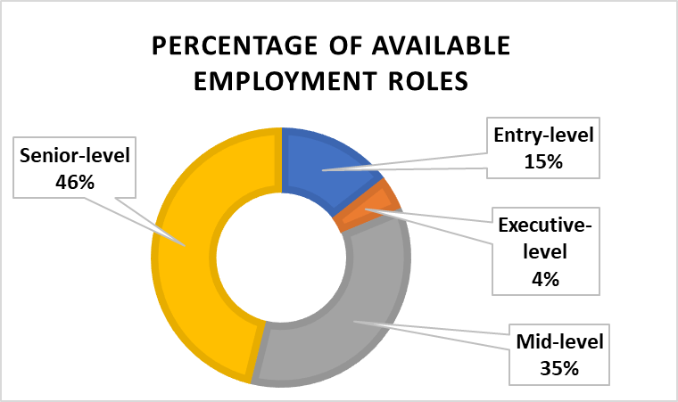

**DATA SCIENCE EMPLOYMENT BY JOB TYPE**

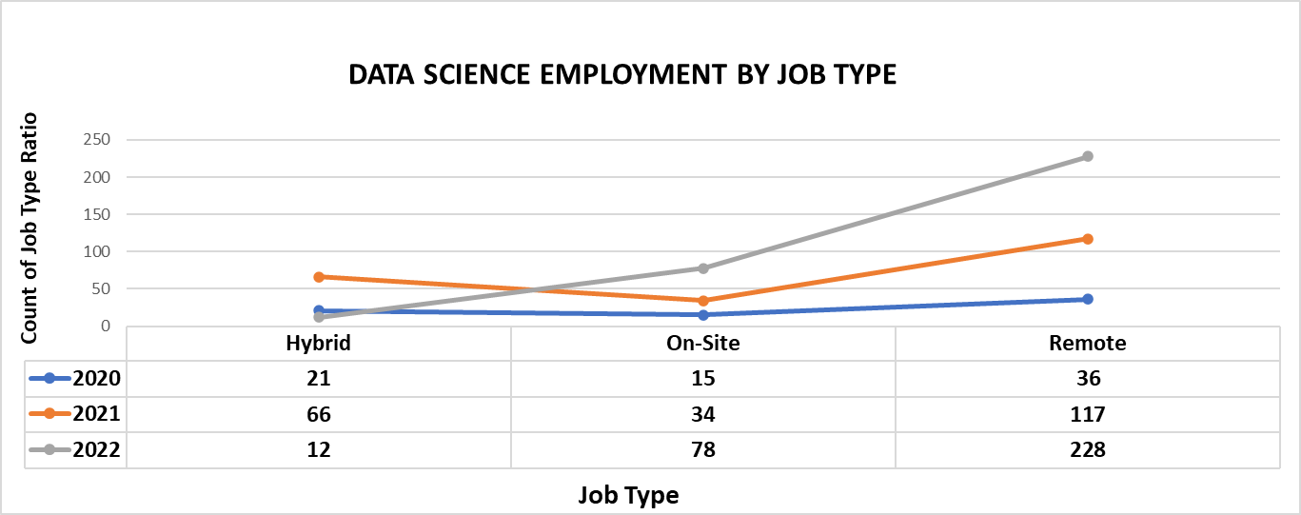

The years spanning 2020 to 2022 witnessed a rise in remote job categories within the Data Science sector. This shift towards remote roles could potentially reflect the growing acknowledgement of the data field's significance, prompting individuals to transition. Additionally, the global impact of the COVID-19 pandemic on work dynamics might have played a role in driving this trend.

**AVERAGE SALARIES BY EXPERIENCE**

This visualization shows the distribution of the average salary paid to these experience levels across the years 2020, 2021 and 2022. As expected, the average salaries vary by the experience level and as one progresses in the field, the salary tends to increase. For each level, it can also be seen that there is no substantial increase in salaries over the three years of study. 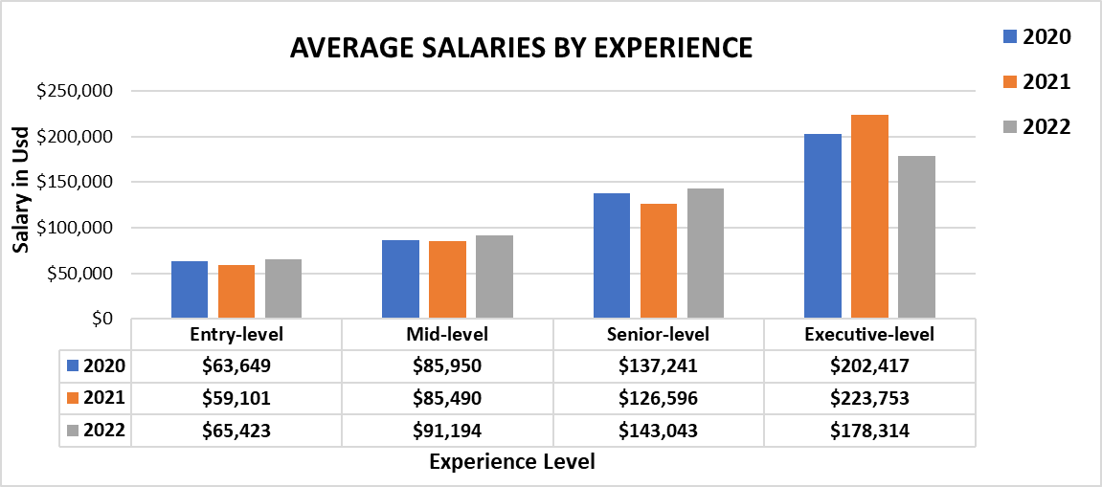

**AVERAGE SALARIES BY COMPANY SIZE**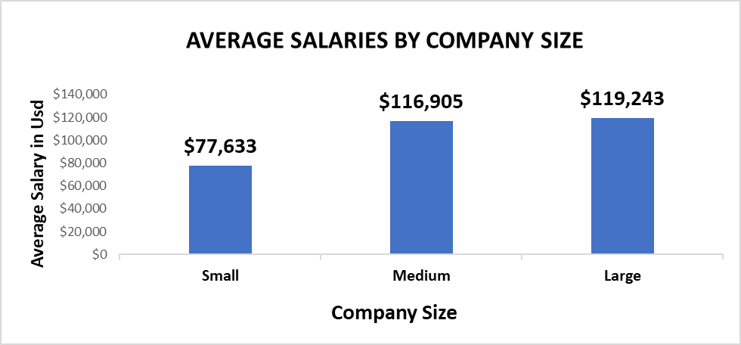

The presented visualization illustrates the average salaries offered to employees according to the size of the company. Evidently, smaller companies tend to offer lower average salaries, with an average of $77,633. Following this, medium-sized companies and large enterprises offer comparatively higher salaries. Notably, the distinction in average salaries between medium-sized and large-sized companies is negligible.

**AVERAGE SALARIES BY EMPLOYMENT TYPES**

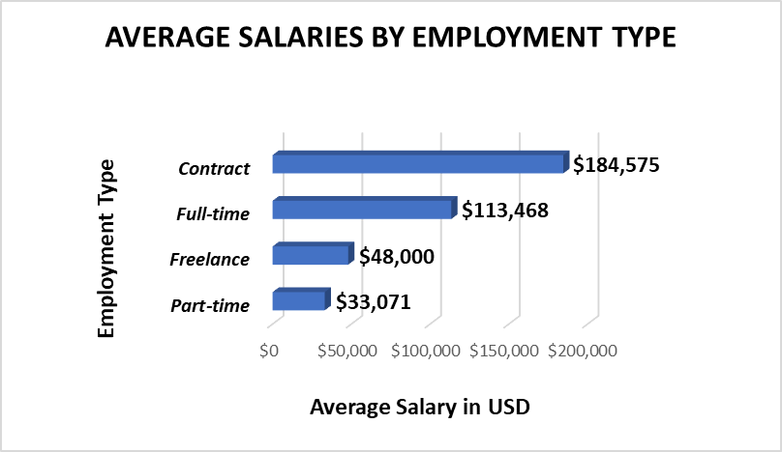

In the presented visualization, I have delved into the average salaries earned by data science practitioners across various employment classifications. Notably, individuals engaged as contract workers exhibit significantly higher average earnings compared to their full-time counterparts. This discrepancy could potentially be attributed to the flexibility of contract roles, which might enable individuals to manage multiple engagements concurrently. Additionally, it is intriguing to observe that freelancers, on average, surpass part-time employees in terms of earnings. This insight sheds light on the intricate dynamics of employment arrangements within the data science domain.

**AVERAGE SALARIES BY JOB TITLES**

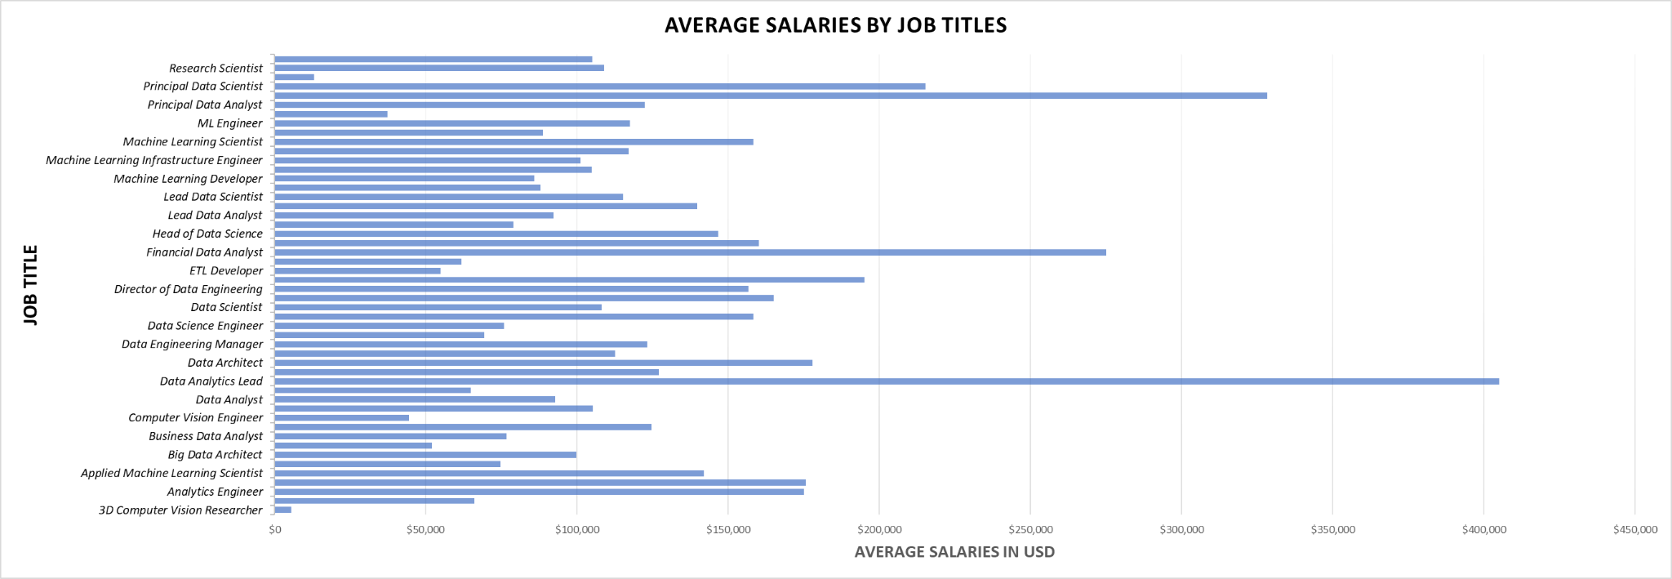

The provided visualization illustrates job titles alongside their corresponding average salaries. Notably, the job role of "**Data Analytics Lead**" commands the highest average salary at $405,000. Following closely is the position of "**Principal Data Engineer**," boasting an average salary of $328,333. Ranking third, the job title "**Financial Data Analys**t" secures an average salary of $275,000. These findings offer valuable insights to individuals contemplating a career path within the data field, aiding informed decisions regarding specialization.

**INSIGHTS**

1. According to the dataset, There are more job opportunities at the senior level roles in the data science sector.
2. This analysis shows a significant increase in remote job types in the data science sector over the years.
3. As expected, the executive level of experience earns more on average than other levels which emphasizes the importance of continuous self-development and advancement.
4. Large company sizes offer more salary potential to employees compared to medium company sizes and start-ups.
5. Contract employees earn more on average than full-time employees, but these two employment types are nothing compared to the freelancing and part-time employment types.
6. According to the dataset, Data Analytics Leads are the highest-paid job titles on average followed by Principal Data Engineer and Financial Data Analyst respectively.

**CRITICISMS**

1. This analysis is restricted to a dataset collected for the United States of America, a better analysis can be done if a dataset that covers other parts of the world.
2. Better insights can be derived from the dataset as not all insights were covered in this report. Refer to the dashboard file to see more.
3. The dataset used to carry out this analysis work might not be reliable as the source of the dataset is from a secondary source and it could be outdated.